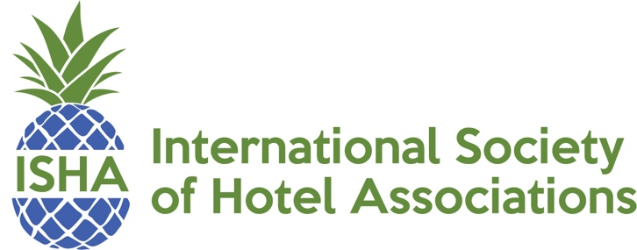

**Executive Director  
Christina Pappas**

**Chair  
Jennifer Flohr**   
Senior Vice President   
California Hotel & Lodging Association

**Immediate Past Chair  
Solomon Keene, Jr**   
President

Hotel Association of Washington D.C.

**1st Vice Chair**

**Eric Terry**

President

Virginia Restaurant, Lodging & Travel Association

**2nd Vice Chair**

**Mindy Hanan**

President & CEO

Alabama Restaurant & Hospitality Association

**Treasurer/Secretary**

**Paul Sacco**

President & CEO

Massachusetts Lodging Association

**Member-At-Large**

**Lynn Minges**

President & CEO

North Carolina Restaurant & Lodging Association

**Member-At-Large**

**Dannette Lynch**

Director of Membership

Florida Restaurant & Lodging Association

**Member-At-Large**

**Alicia Maltby**

Executive Director

Alaska Hotel and Lodging Association

**Member-At-Large**

**Scott Joslove**

President & CEO

Texas Hotel & Lodging Association

**2018 ISHA AWARD ENTRY CATEGORIES**

The following seven categories are available for entry submission:

Communications – A program or project that positively impacts the association’s communication to members and stakeholders.

Public Relations – A program or project that positively highlights the activities of the association to external audiences.

Education/Workforce Development – A program or project that introduces new employees, demonstrates an effective training mechanism, or otherwise enhances knowledge of our industry.

Events and Fundraising – A program or project that clearly raised significant funds for a industry related cause and/or an event that experienced a dramatic increase in attendance, industry visibility and/or net profitability.

Governmental Affairs – A program or project that effectively communicates the message of governmental activities, or demonstrates success in championing an industry cause.

Member Programs – A program or project that shows performance results through increases in members or retention of members.

**374 Marlborough Street, Boston, MA 02115 phone: 617.536.0590 email: cpappas@ishae.org**