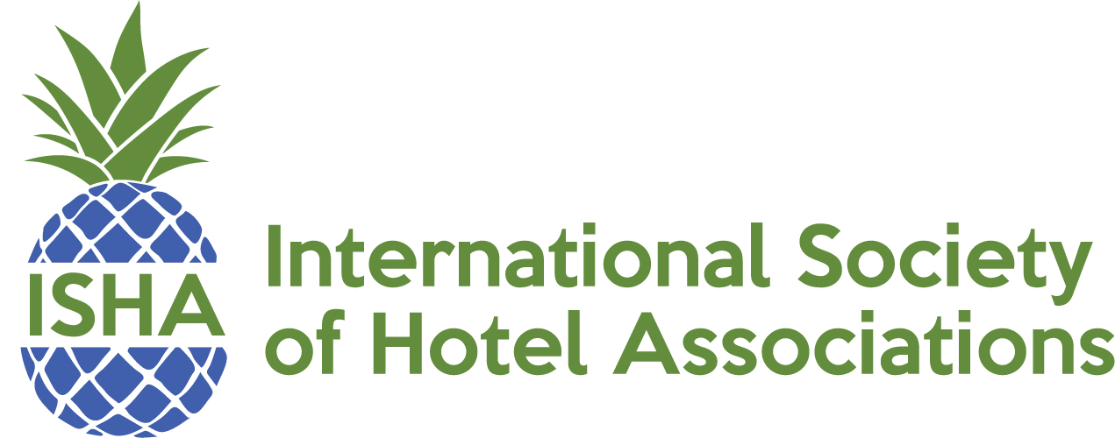

2019 ISHA AWARDS OF EXCELLENCE APPLICATION

Entries must be for projects completed by January 1, 2019 through September 30, 2019.

Name____________________________________Title______________________________

Association_________________________Email_____________________________________

City_______________________ State________________ Zip_________________________

Phone___________________________________Fax_________________________________

Association Staff Size___________________________________________________________

Associations Annual Budget (not including AH&LA dues): ___Over $500,000 ___Under $500,000

Entry Category: _____Education and Workforce Development ____Events and Fundraising

____Government Affairs ____Member Programs _____Public Relations ____Communications

Please respond to the following questions on a separate piece of paper.

- Goals & Objectives of Program

- Target Audience

- Results of Program

- Evaluation Measures

- How was the program presented to the Target audience?

- Addition information

ENTRIES MUST BE RECEIVED NO LATER THAN OCTOBER 4, 2019

