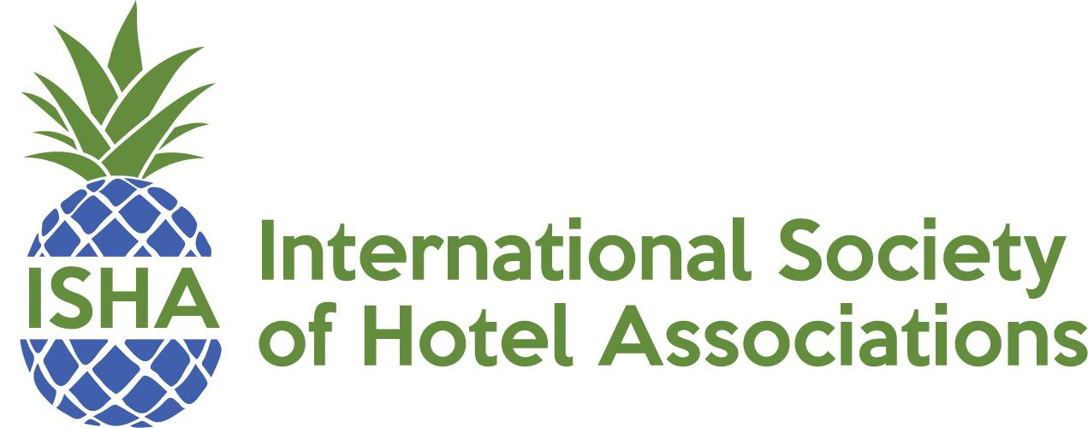

ISHA 2022 Event & Deadline Calendar

ISHA Summer Meeting
June 15 - 17, 2022, The Logan Hotel, Philadelphia, PA
Summer Conference Scholarship Application Deadline: March 11, 2022
Summer Conference Scholarship Recipients Notified by March 18, 2022

Summer Conference Early Bird Registration: April 29, 2022
Summer Conference Registration Closes: June 1, 2022

ISHA Awards of Excellence
ISHAE Awards of Excellence Submissions due by October 12, 2022
Awards announced at Winter Conference

CAE Scholarships
CAE Scholarship Applications due by November 18, 2022
Scholarships Announced at Winter Conference

Winter Conference
December 5 - 7, 2022, Coronado Island Marriott Resort, San Diego, CA
Winter Conference Scholarship Application Deadline: August 26, 2022
Winter Conference Scholarship Recipients Notified by September 2, 2022

Winter Conference Early Bird Registration Deadline: October 14, 2022
Winter Conference Registration Deadline: November 18, 2022

