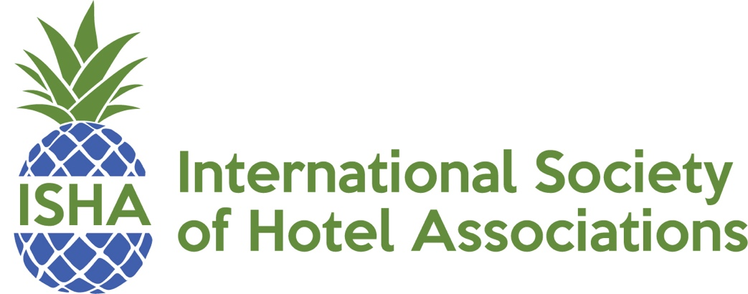
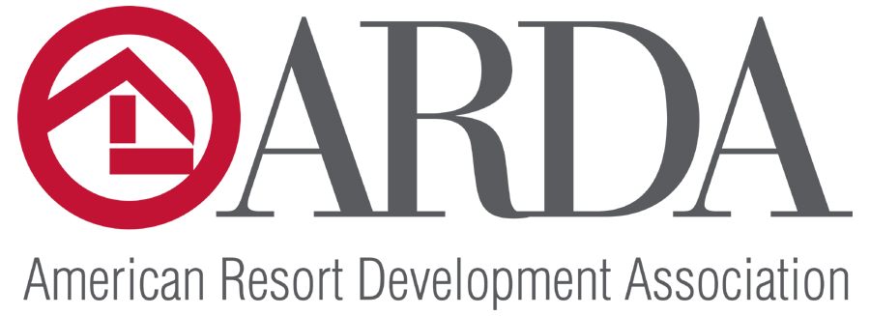

ISHA/American Resort Development Association (ARDA)
Certified Association Executive
Scholarship Fund Eligibility Criteria

ISHA and ARDA are pleased to provide this professional development opportunity to ISHA members. The Certified Association Executive (CAE) program is designed to elevate professional standards, enhance individual performance, and designate association professionals who demonstrate the knowledge essential to the practice of association management. The CAE is the highest certification for the association industry. ISHA now offers you the opportunity to go for the gold and earn your CAE certification! Your exam fee will be paid in full by ISHA/ARDA Scholarship Fund.

Applicants should have been an ISHA member for at least a year prior to eligibility. (2024 applicants must have been an ISHA member prior to September 30, 2023.)

Applicants must submit a letter stating their intent to the commitment and maintenance of the CAE certification.

Applicants should be willing to give back by mentoring future CAE candidates during their preparation for the test.
Applicants must be eligible to sit for the CAE at the time the application is submitted.
To qualify to take the CAE exam, applicants must:
- Be currently or recently employed in a qualifying nonprofit organization or association management company.
- Have sufficient qualifying professional experience.
- Have completed 75 hours of broad-based qualifying professional development within the last five years. The CAE Commission strongly recommends that you fulfill the professional development requirement by completing coursework in proportion to the weighting of each content area on the exam content outline.
- Sign an attestation to uphold ASAE's Standards of Conduct.
- For a complete list of eligibility and more info go to www.whatiscae.com.
Scholarships received in December are for the following year test dates. (2024 for 2025)
CAE Scholarship funds will be distributed upon receipt of confirmation that recipient
has completed the CAE testing.

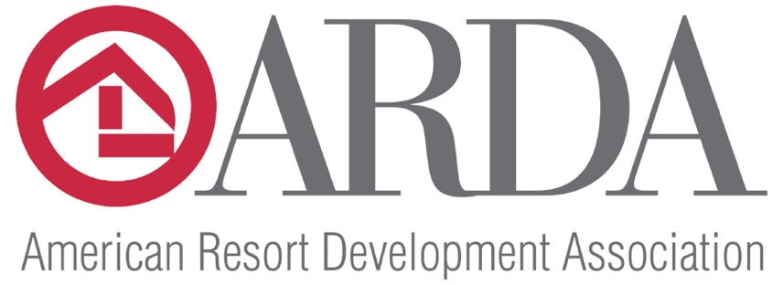

ISHA/American Resort Development Association
Certified Association Executive
Scholarship Application

Name:_ __________________________________________
Association: _ ______________________________________
Title: ___ _________________ Number of yrs in position: _ ___
Number of yrs in Association Management: ___ ______

Do you meet all the requirements of CAE eligibility as defined by ASAE: _____ ____
How long have you been a member of ISHA? __ _____________________
Are you an ASAE member? (This will have no bearing on your eligibility.) ____ _____

Explain why receiving the CAE certification is important to you. Use additional paper if necessary.

Scholarship Applications for 2025 must be received by November 8, 2024
Email to cpappas@isha.biz

