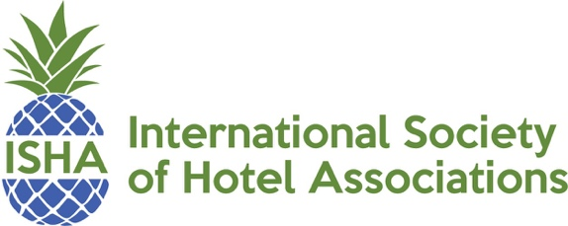

2020 ISHA Partners
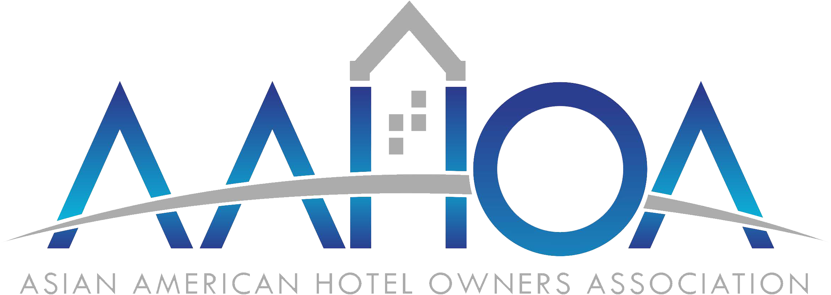
In 2014, the Asian American Hotel Owners Association (AAHOA) celebrated its 25th anniversary and is currently one of hospitality industry’s leading voices for hotel owners and operators. AAHOA represents nearly 14,000 members nationwide, who own more than 20,000 properties, amounting to more than 40% of all hotels in the United States. AAHOA members employ over 600,000 American workers, accounting for nearly $10 billion in payroll annually. To learn more about AAHOA and its mission, please visit www.aahoa.com. Contact: Chirag Shah, Vice President for Government Affairs, 202-507-6151, chirag@aahoa.com
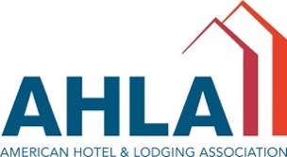

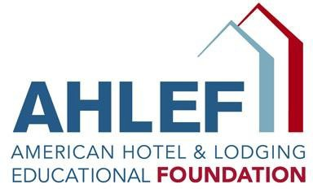
American Hotel & Lodging Association; American Hotel & Lodging Association Educational Foundation (AH&LA, AH&LAEF) is the voice of the lodging industry, an outspoken advocate and indispensable resource for the $113 billion lodging sector. Members benefit from product and service discounts, world-class training, in-depth information, fast research support, and a wealth of other resources. Contact: AH&LA, Kevin Carey, Executive Vice President and Chief Operating Officer, kcarey@ahla.com; Troy Flanagan, Vice President, Government Affairs & Industry Relations, tflanagan@ahla.com; Shelly Weir, Senior Vice President of Career Development, sweir@ahla.com

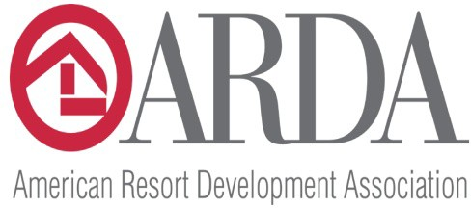
American Resort Development Association (ARDA) is the Washington D.C.-based professional association representing the vacation ownership and resort development industries. Established in 1969, ARDA today has nearly 1,000 corporate members ranging from privately held firms to publicly traded companies and international corporations with expertise in shared ownership interests in leisure real estate. The membership also includes timeshare owner associations (HOAs), resort management companies, and owners through the ARDA Resort Owners Coalition. Contact: Chris Stewart, Director, State Government Affairs, 407-245-7601, cstewart@arda.org

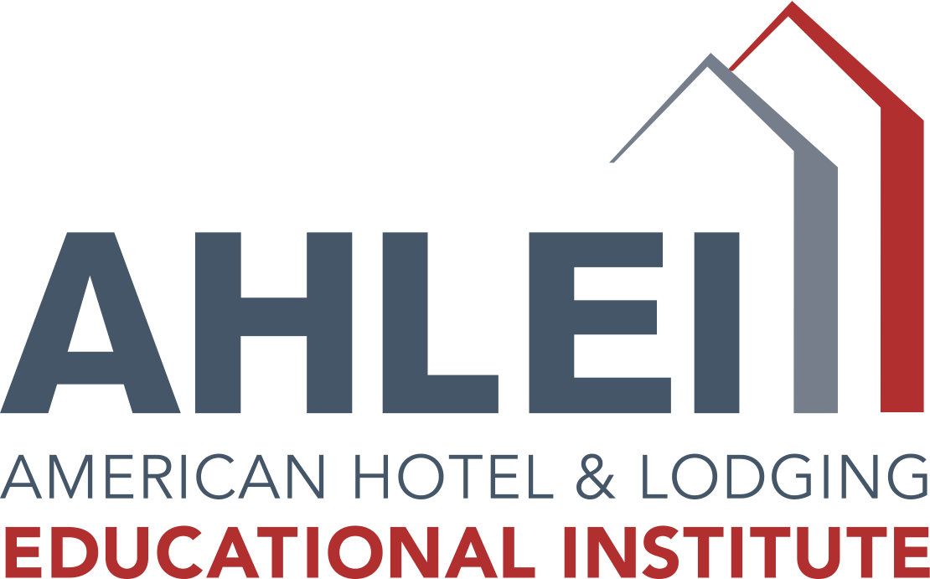
For more than 65 years, AHLEI has worked to provide industry, hospitality organizations, schools, colleges and universities with quality resources to train, educate, and certify hospitality professionals with an extensive product line includes online courses, skills guides, textbooks (print and digital), DVDs and more. AHLEI administers 20-plus professional certification programs for all levels of one’s hospitality career, from line-level to general manager. Workforce development agencies can also take advantage of strong foundational programs to start new employees on a career in hospitality with the Certified Guest Service Professional program and six certifications for front-line employees. Contact: Alisha Gulden, Vice President of Sales, Training & Certification, 312-715-5370, agulden@restaurant.org

MemberClicks provides a suite of software solutions for member-based organizations. From membership management systems to a learning management system to a job board to a conference app - and beyond - MemberClicks has everything organizations need to do so much more - for their members, industry, and community. Founded in 1998, MemberClicks serves 3,000 customers throughout North America. Contact: Laura Sanders, Director Of Sales, 800-914-2441, laura@memberclicks.com

UnitedHealth Group is a diversified health care company dedicated to helping people live healthier lives and helping make the health system work better for everyone. UnitedHealth Group offers a broad spectrum of products and services through two distinct platforms: UnitedHealthcare, which provides health care coverage and benefits services; and Optum, which provides information and technology-enabled health services. Contact: Kimberlee Vandervoorn, Vice President, Distribution Services, 301-865-7058, kvandervoorn@uhg.com

Heartland Payment Systems provides credit and debit card, payroll, and related processing services to restaurant, hotel, and retail merchants throughout the United States. HPS provides services to over 250,000 merchants with over 1,000 Relationship Managers out of a team of over 2,300 employees in operations, sales, IT, marketing and administration. Heartland processed its first card transaction on July 15, 1997 with a business investment of $41 million. Today, Heartland has become the sixth largest payment processor, with over $55 billion of annual processing volume from current merchants. Contact: Bobby Hidgon, Business Development Manager, 888-798-3133 ext. 11577, robert.higdon@heartland.us

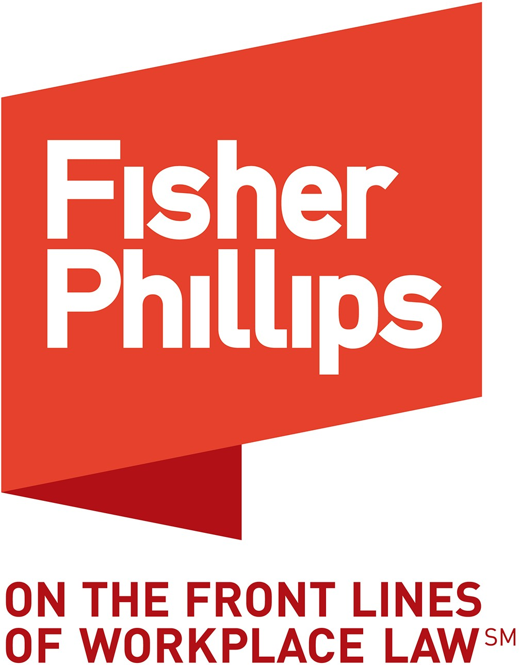
Fisher Phillips LLP represents employers nationally in labor, employment, civil rights, employee benefits and immigration matters. The Hospitality Industry Practice Group (HIPG) includes attorneys that advise and represent many of the largest hotel and gaming companies in the country, along with dozens of individually owned hotels, restaurants, spas & other members of the hospitality industry. We help prevent legal problems and provide day-to-day advice and consultation on every aspect of labor and employment law. Contact: Andria Lure Ryan, Partner, 404-240-4219, alureryan@laborlawyers.com

Pyramind LLC is a woman-owned, retained executive search firm that delivers quality, senior-level talent to leading enterprises and organizations. By applying professionalism, integrity and a targeted approach to recruitment, Pyramind achieves successful placement results for a wide ride of clients. Contact: Hope Johnson, President and CEO, 703-622-9088, hope@pyramindsearch.com

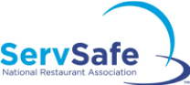
Celebrating 30 years of offering best in class food safety training, the ServSafe programs created by the National Restaurant Association, are widely recognized and respected in the foodservice industry. Under the guidance of scientists and industry specialists – the ServSafe program provides Food Handler, Manager Food Safety, and Responsible Alcohol, and Allergen training and certification designed to reduce risk to your business and help you meet local regulatory requirements. Contact: Alisha Gulden, VP of Sales, Training & Certification, 312-715-5370, agulden@restaurant.org

Customers are at the core of everything Dell does. Dell is focused on delivering affordable business solutions that enable small business owners to make smarter decisions that impact their bottom line. ISHA has partnered with Dell to bring members savings (up to 30-40% off the everyday price) on their systems and Dell branded electronics and accessories. See why Dell has all the technology, expertise and service you need to build and maintain an efficient home and business workspace. Visit dell.com/ISHA. Contact: Steve Shipe, Strategic Partnerships, 615-545-7786, steven-shipe@dell.com

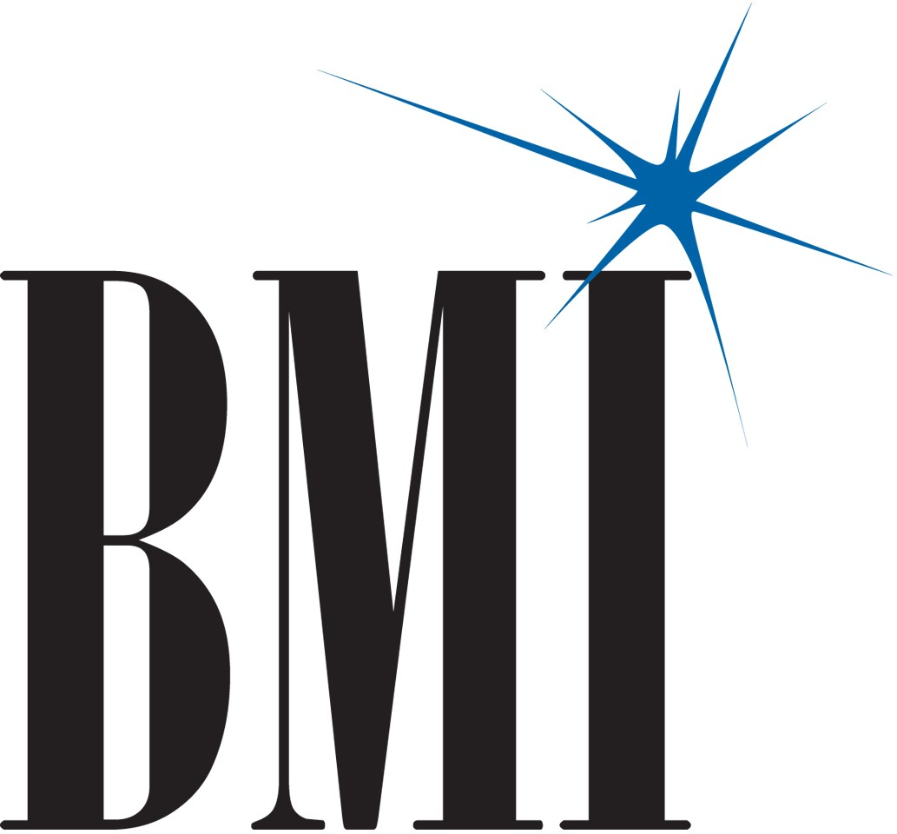
BMI is the bridge between songwriters and the businesses and organizations that want to play their music publicly. As a global leader in music rights management, BMI serves as an advocate for the value of music, representing more than 7.5 million musical works created and owned by more than 600,000 songwriters, composers and music publishers. Contact: Dan Spears, Vice President of Industry Relations, 410-527-1076, dspears@bmi.com

Merchant Services is the global payment acceptance and merchant acquiring business of J.P. Morgan and a leading provider of payment, fraud management and data security solutions, capable of authorizing transaction in more than 130 currencies. The company processed nearly $1.4 trillion in merchant processing volume in 2018 and is a world-leading merchant acquirer. Contact: Faheem Khan, Executive Director & Business Development Senior Director, Hostpitality & Real Estate, J.P. Morgan, Merchant Services, 972-324-5510, faheem.khan@chase.com

Source1 Purchasing is a group purchasing organization supporting the hospitality industry by providing access to nationally contracted pricing, dedicated account management and specialized member programs that create significant value within their supply chain. Contact: Santiago Arango, Program Director, 561-273-7950, Santiago.Arango@Source1Purchasing.com

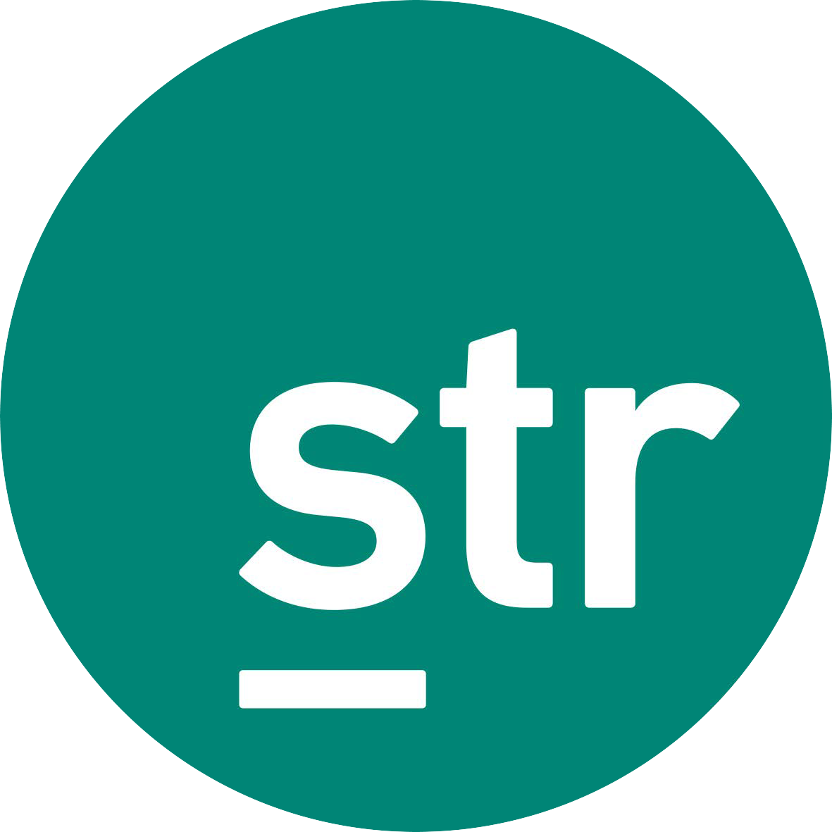
STR is the leading global provider of competitive benchmarking, information services and research to the hotel industry. Our data reporting empowers hoteliers, as well as third-parties affiliated with the hotel industry, to make sound decisions by providing actionable performance data. Contact: Melissa Holm, Business Development Executive, Hotels, 615-824-8664 x3468, mholm@str.com

AiRISTA Flow provides an end-to-end panic button solution for hotel employee safety. Delivered from the cloud or on-prem, AiRISTA Flow draws from a range of technologies, a variety of tag options, and focuses on program flexibility to address requirements of individual properties and management groups alike. For over 10 years, our solutions, specialized development and integration capabilities have led the way to successful deployments in some of the most challenging environments. Contact: Brandan J. Wolf, Sales Engineer, 262-853-5107, brandan.wolf@airistaflow.com

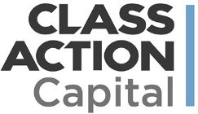
Class Action Capital is a provider of class action settlement claim management and monetization to the global corporate community. Launched in 2012, CAC has quickly gained traction amongst the corporate community to become the premier provider of outsourced class action settlement claim management and monetization. From 30 clients in 2012 to over 4,000 clients to date, CAC's value proposition, reputation and expertise has been recognized by companies of all sizes in diverse industries. Contact: Joshua Kerstein, Director of Strategic Partnerships, 941-200-0066, josh@classactioncapital.com

Wellspring Info helps organizations improve and deliver their emergency response plans through quick-reference guidebooks and mobile apps. Wellspring Info clients include Loews, Extended Stay, Wyndham, Holiday Inn, IHG, Petra Risk Solutions & Marriott. Wellspring Info can create a landing page which gives your hotel members discounted pricing on emergency response apps and emergency guidebooks. They'll brand the landing page for you, free of charge. To see a sample, please go to WellspringInfo.com/ISHAE. Contact: Scott Cohen, Chief Executive Officer, 800-268-3682 x118, scott@wellspringinfo.com

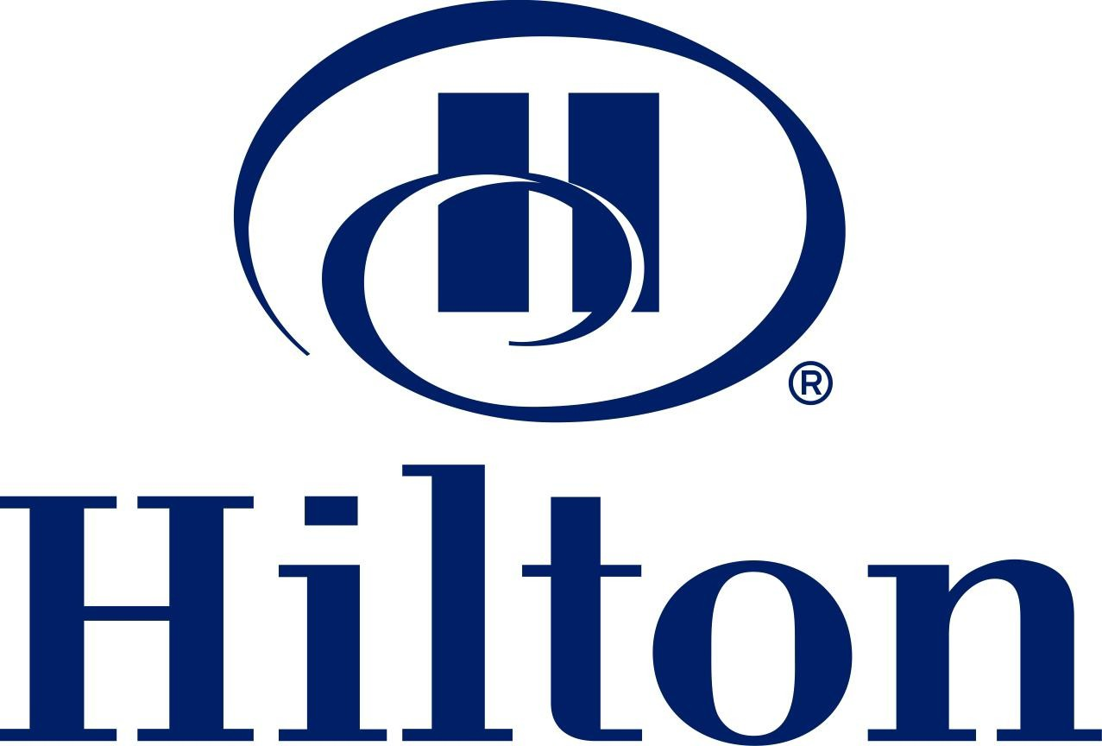
Hilton Worldwide is a leading global hospitality company, spanning the lodging sector from luxurious full-service hotels and resorts to extended-stay suites and mid-priced hotels. Contact: Erica Gordon, VP, Government Affairs, 703-883-5382, erica.gordon@hilton.com and Scott Nowak,
Senior Manager, State & Local Government Affairs, 703-883-6917, scott.nowak@hilton.com

Hyatt is a global hospitality brand with one driving purpose: to care for people so they can be their best. Our commitment to this purpose is evidenced by our 60-year history of high standards and quality; our portfolio of 20 premier brands spanning 875 properties, 60 countries, and six continents; our thoughtful offerings for business & leisure travelers; and our global footprint with extensive reach. Our loyalty program, World of Hyatt, allows us to deepen our relationship with our community of loyalists, and drive them to interact with our brand in new ways—supporting our strategy to create new experiences that go beyond hotel stays. Contact: Eileen Rainey, Director, State & Local Tax (Tax Dept), 312-780-5491, eileen.rainey@hyatt.com; Rob Schnitz, SVP & Associate General Counsel, rob.schnitz@hyatt.com; Savanna Barclay, Sr. Mgr, Indirect Tax (Finance), 312-780-5462, savanna.barclay@hyatt.com

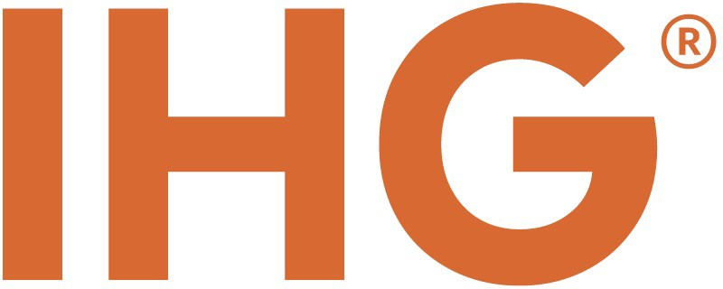
IHG® (InterContinental Hotels Group) is a global organization with a broad portfolio of hotel brands, including: InterContinental® Hotels & Resorts, Kimpton® Hotels & Restaurants, HUALUXE®, Crowne Plaza® Hotels & Resorts, Hotel Indigo®, Holiday Inn®, EVEN™ Hotels, Holiday Inn Express®, Staybridge Suites® and Candlewood Suites®. IHG franchises, leases, manages or owns more than 5,000 hotels and 744,000 guest rooms in nearly 100 countries, with more than 1,300 hotels in its development pipeline. IHG also manages IHG® Rewards Club, the world’s first & largest hotel loyalty program with over 92 million members worldwide. Visit ihg.com for hotel information. Contact: Melanie de La Grange Sury, Mgr. Public Affairs, 770-604-5538, melanie.delagrangesury@ihg.com

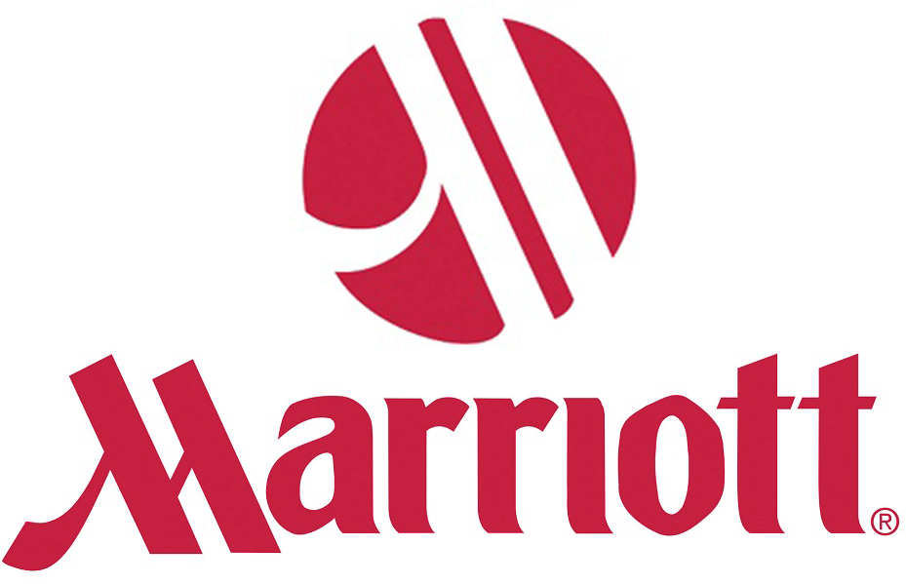
Marriott International, Inc. is a global hotel and lodging company with more than 3,700 lodging properties in 74 countries and territories around the world. The company’s portfolio of eighteen brands includes the signature Marriott Hotels and Resorts line, Ritz-Carlton, Renaissance Hotels, Courtyard by Marriott and recently added Gaylord Hotels. Contact: Thomas “T.J.” Maloney, Senior Director, Government and Public Affairs, 301-380-3158, thomas.maloney@marriott.com

ISHA Affinity Partners
Select partners offer revenue share & discount opportunities to ISHA members and your members. See below for details.

Class Action Capital is a provider of class action settlement claim management and monetization to the global corporate community. With over 4,000 clients to date, CAC’s reputation & expertise has been recognized by companies of all sizes and industries. By working with Class Action Capital to promote claims to members, ISHA lodging association members receive a percentage of revenue share when a claim is settled in their state. To learn more, contact Joshua Kerstein at josh@classactioncapital.com or visit www.classactioncapital.com

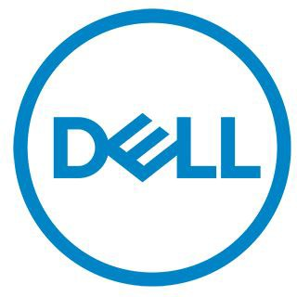
Dell is proud to provide small business owners with affordable solutions that that impact their bottom line. They have everything you need to build and maintain an efficient home and business workspace. ISHA has partnered with Dell to help members save up to 30-40% off on their systems, Dell branded electronics & accessories. Visit www.dell.com/ISHA to view all current offerings. Purchases must be made with ISHA's member ID# 530002874491.

Source1 Purchasing is a group purchasing organization that supports the hospitality industry by providing access to nationally contracted pricing, dedicated account management and specialized member programs that create significant value within their supply chain. Source1 also gives associations the chance to earn additional revenue by becoming chapter partners and enrolling their members in the Source1 Program. For more details, contact Santiago Arango at 561-797-7844 or at Santiago.Arango@Source1Purchasing.com

As part of a strategic alliance program with UnitedHealth Group, ISHA lodging association members have access to exclusive discounts and solutions that can be promoted to your members. This alliance program provides access to affordable health care options, promotes health and wellness in the hospitality industry, and helps members navigate state & federal compliance areas. It also features special offers from industry leaders like Optum® & UnitedHealthcare®. To learn more, email Kimberlee Vandervoorn at kvandervoorn@uhg.com.

Wellspring Info helps your members deliver their emergency response plans through quick-reference guidebooks and mobile apps. By helping to promote them, Wellspring will offer 2% commission to ISHA members. In addition, Wellspring is offering all lodging association members a 10% discount on their emergency response apps & guidebooks if you order by December 31, 2020. For more information, go to WellspringInfoApp.com or email Scott Cohen at Scott@WellspringInfo.com

