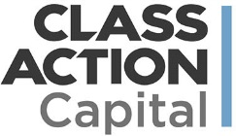
Class Action Capital provides class action claim management and monetization to the global corporate community. It’s as simple as promoting available claims to members and introducing them to Class Action Capital. In return, state lodging associations receive a percentage of revenue share when a claim is settled in their state. For more information, please visit www.classactioncapital.com or contact Joshua Kerstein at Josh@ClassActionCapital.com.
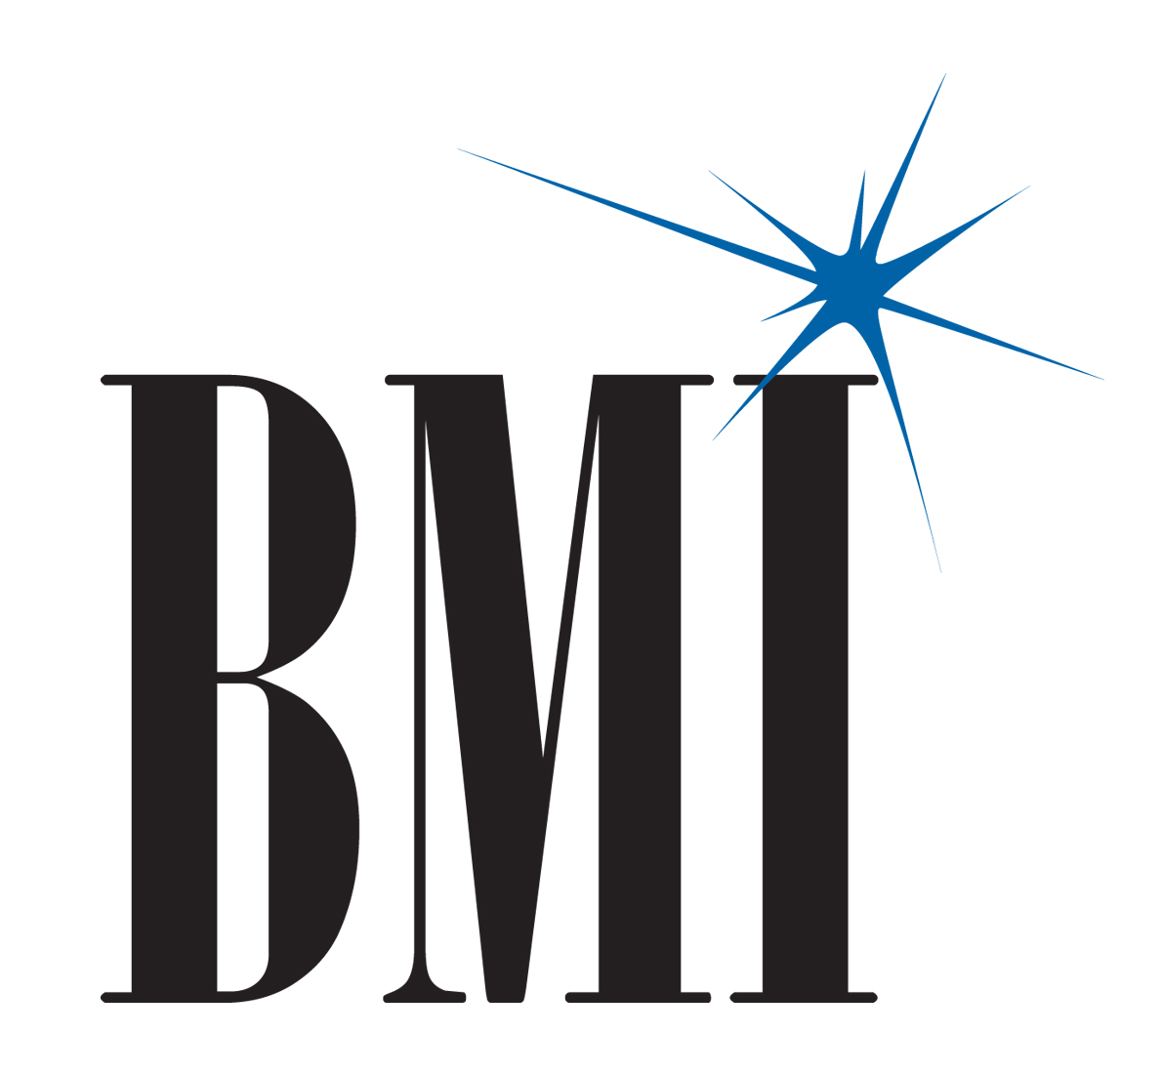
BMI is the bridge between songwriters and the businesses and organizations that want to play their music publicly. As a global leader in music rights management, BMI serves as an advocate for the value of music, representing more than 7.5 million musical works created and owned by more than 600,000 songwriters, composers and music publishers. As a member of ISHA, you can offer your members 1% off of their BMI licensing fees. For more information, contact Josh Lagersen at jlagersen@bmi.com.

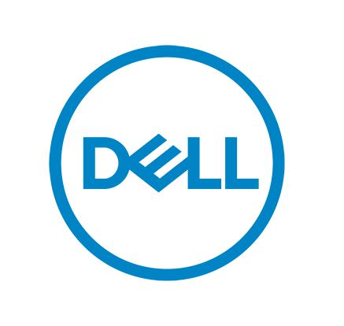
As an ISHA member, your association and your members receive discounts on Dell products. Dell offers quarterly deals and incentives, which ISHA communicates through dedicated e-mail blasts. We also post these offers on www.ishae.org and provide copy you can use in communications to your members. All of your members are able to take advantage of these Dell offers, and we encourage you to share them in your monthly newsletters. In order to receive revenue share, purchases must be made with the use of ISHA’s Member ID# 530002874491. It’s a win-win for the state, your members, and ISHA!

Visit www.dell.com/ISHAE to view all of the current offerings and share with your members.

As an ISHA member, FrontStream offers your association various software platforms and suites of tools including auction, peer to peer and donor management – all at significant discounts:
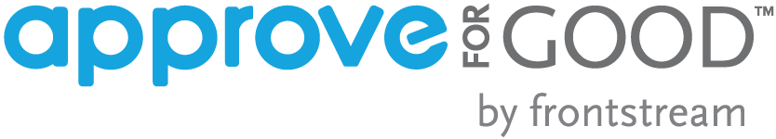
- Panorama: 30% off for Year 1 of all of its Panorama suite of tools: auction, peer to peer and donor management.
- Panorama Workplace: 20% off to grow corporate CSR programs. Panorama Workplace allows corporations to create meaningful workplace fundraising campaigns for disaster relief or special employee initiatives, and manage employee giving, volunteering, and matching in a powerful, all-in-one platform.
- ApproveForGood: Discounted rate of $900 annually

GrowthZone offers association management software that is cloud-based, powerful, easy to use, and designed to manage all the day-to-day operations of an organization. GrowthZone is offering a special discount to ISHA state associations with 25% off all setup fees, plus $500 off a new website design. Please contact Derek Owen at derek.owen@growthzone.com to learn more and to schedule a free demo.

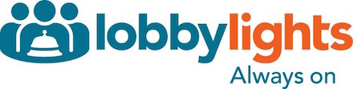
LobbyLights wage and benefit survey is a total compensation survey specifically designed for the hospitality industry. They partner with state associations and offer the surveys as a member benefit. LobbyLights will reach out to your members to introduce the benefit, answer their questions and help them complete the survey. When states engage and work with LobbyLights, the state association creates an additional value add benefit for hotel members. For more information on the survey, pricing and how LobbyLights offers complete services to your members, please contact Kevin Conway at kconway@lobbylights.com.

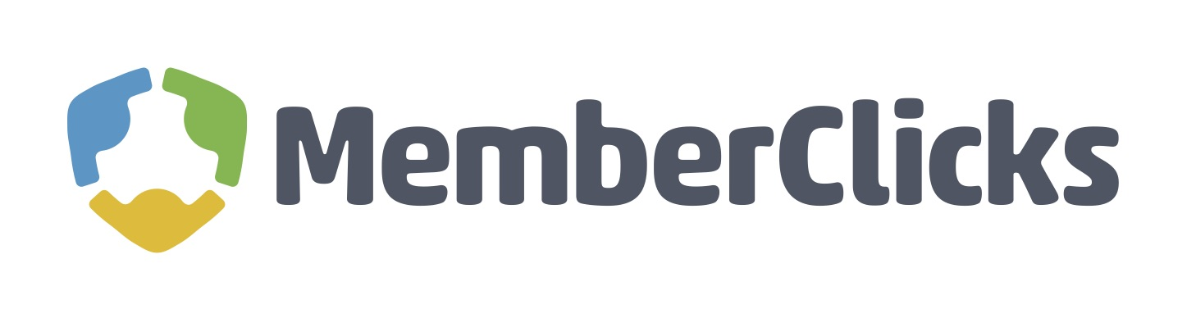
MemberClicks is a membership management software company designed to empower associations and chambers. They provide an experience designed to help associations save time and resources. From powerful dues automation and event registration features to custom-designed websites, email marketing and member communities, their products are tailor-made for small staff associations. As an ISHA member, you can receive database discounts and 30% off any website service costs. To learn more, contact Sarah Freese at sfreese@memberclicks.com.
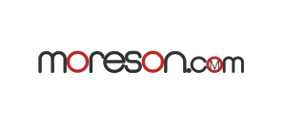
Moreson Conferencing is an established global teleconferencing business. They have developed one of the most successful and user-friendly reservation-less conference solutions in the industry. Moreson is offering ISHA members a preferred rate of 1.9/cents/minute ($0.019). To establish a new account, simply send an email to ishae@moreson.com and reference this offer (ISHAE2018).

Wellspring Info can help hotels improve their emergency response plan and then turn it into quick-reference emergency guidebooks or an emergency response app, at a discounted rate for ISHA state lodging associations and their hotel members. Their clients include Loews, Holiday Inn, Wyndham, IHG and Marriott. We encourage you to promote Wellspring to your members in your newsletters and on your website. To learn more visit www.wellspringinfo.com/ISHAE or contact Scott Cohen at scott@wellspringinfo.com.

Windfall is a leading provider of member benefit programs for hundreds of associations, franchises, and businesses. They provide exclusive discounts on business products and services as well as personal benefits to members. As an ISHA member, these discounts are available to your association and your members. Request your own individual state association benefit program by visiting ISHAE.SavingCenter.Net.

