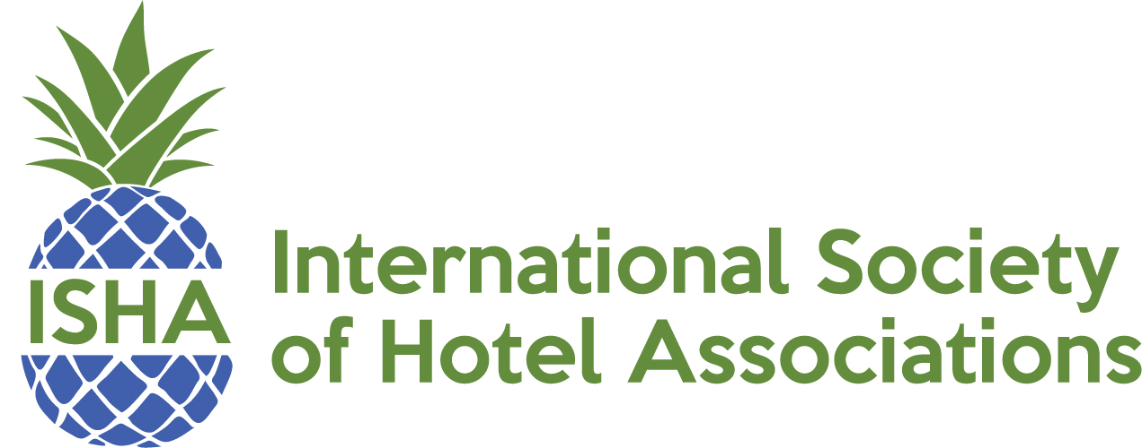

ISHA Membership Calls 2018

First Tuesday of every other month
2 PM EST

- January 9
- March 6
- May 1
- July 3
- September 4
- November 6

